**FEASIBILITY REPORT**

**FEASIBILITY REPORT**

**TECHNICAL FEASIBILITY:**

Evaluating the technical feasibility is the trickiest part of a feasibility study. This is because, at this point in time, not too many detailed design of the system, making it difficult to access issues like performance, costs on (on account of the kind of technology to be deployed) etc. A number of issues have to be considered while doing a technical

analysis.

1. **Understand the different technologies involved in the proposed system:**

Before commencing the project, we have to be very clear about what are the technologies that are to be required for the development of the new system.

1. **Find out whether the organization currently possesses the required technologies:**
   * Is the required technology available with the organization?
   * If so is the capacity sufficient?

For instance –

“Will the current printer be able to handle the new reports and forms required for the new system?”

**OPERATIONAL FEASIBILITY:**

Proposed projects are beneficial only if they can be turned into information systems that will meet the organizations operating requirements. Simply stated, this test of feasibility asks if the system will work when it is developed and installed. Are there major barriers to Implementation? Here are questions that will help test the operational feasibility of a project:

* Is there sufficient support for the project from management from users? If the current system is well liked and used to the extent that persons will not be able to see reasons for change, there may be resistance.
* Are the current business methods acceptable to the user? If they are not, Users may welcome a change that will bring about a more operational and useful systems.
* Have the user been involved in the planning and development of the project?
* Early involvement reduces the chances of resistance to the system and in
* General and increases the likelihood of successful project.

Since the proposed system was to help reduce the hardships encountered. In the existing manual system, the new system was considered to be operational feasible.

**ECONOMIC FEASIBILITY:**

Economic feasibility attempts 2 weigh the costs of developing and implementing a new system, against the benefits that would accrue from having the new system in place. This feasibility study gives the top management the economic justification for the new system.

A simple economic analysis which gives the actual comparison of costs and benefits are much more meaningful in this case. In addition, this proves to be a useful point of reference to compare actual costs as the project progresses. There could be various types of intangible benefits on account of automation. These could include increased customer satisfaction, improvement in product quality better decision making timeliness of information, expediting activities, improved accuracy of operations, better documentation and record keeping, faster retrieval of information, better employee morale.

**Operating Environment :**

**SOFTWARE REQUIREMENTS**

Operating System : Windows XP/2003 or Linux

User Interface : HTML, CSS

Client-side Scripting : JavaScript

Programming Language : Java

Framework : struts 1.x, Hibernate 3.0

IDE/Workbench : My Eclipse 8.6

Database : Oracle 10g

Server Deployment : Tomcat 6.x

**HARDWARE REQUIREMENTS**

Processor : CORE 2 DUO

Hard Disk : 160GB

RAM : 1GB or more

**Design and Implementation Constraints :**

The system is designed using the Spiral model, with constant interaction with the clients. The implementations design is done thru java Struts, hibernate and jsp with HTML, CSS, and JAVASCRIPT.

The software will be required to be maintained by the TOMCAT 6.0. The website administrator is sole responsible for the maintenance of the site all Users authentication restricted. Sufficient security through firewalls and proxy to be implemented.

It also requires the Oracle 10g database to store and retrieve data.

**Project Planning:**

**SDLC METHODOLOGIES**

This document play a vital role in the development of life cycle (SDLC) as it describes the complete requirement of the system. It means for use by developers and will be the basic during testing phase. Any changes made to the requirements in the future will have to go through formal change approval process.

SPIRAL MODEL was defined by Barry Boehm in his 1988 article, “A spiral Model of Software Development and Enhancement. This model was not the first model to discuss iterative development, but it was the first model to explain why the iteration models.

As originally envisioned, the iterations were typically 6 months to 2 years long. Each phase starts with a design goal and ends with a client reviewing the progress thus far. Analysis and engineering efforts are applied at each phase of the project, with an eye toward the end goal of the project.

The steps for Spiral Model can be generalized as follows:

* The new system requirements are defined in as much details as possible. This usually involves interviewing a number of users representing all the external or internal users and other aspects of the existing system.
* A preliminary design is created for the new system.
* A first prototype of the new system is constructed from the preliminary design. This is usually a scaled-down system, and represents an approximation of the characteristics of the final product.
* A second prototype is evolved by a fourfold procedure:

1. Evaluating the first prototype in terms of its strengths, weakness, and risks.
2. Defining the requirements of the second prototype.
3. Planning an designing the second prototype.
4. Constructing and testing the second prototype.

* At the customer option, the entire project can be aborted if the risk is deemed too great. Risk factors might involved development cost overruns, operating-cost miscalculation, or any other factor that could, in the customer’s judgment, result in a less-than-satisfactory final product.
* The existing prototype is evaluated in the same manner as was the previous prototype, and if necessary, another prototype is developed from it according to the fourfold procedure outlined above.
* The preceding steps are iterated until the customer is satisfied that the refined prototype represents the final product desired.
* The final system is constructed, based on the refined prototype.
* The final system is thoroughly evaluated and tested. Routine maintenance is carried on a continuing basis to prevent large scale failures and to minimize down time.

**The following diagram shows how a spiral model acts like:**

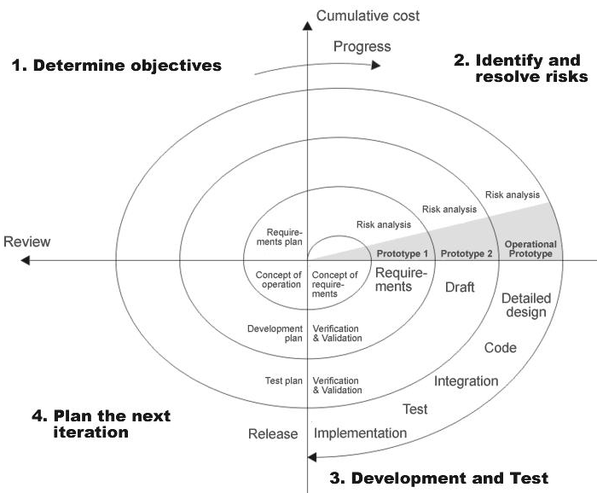

**Fig 1.0-Spiral Model**

**ADVANTAGES**

* Estimates(i.e. budget, schedule etc .) become more relistic as work progresses, because important issues discoved earlier.
* It is more able to cope with the changes that are software development generally entails.
* Software engineers can get their hands in and start woring on the core of a project earlier.

**SYSTEM REQUIREMENT SPECIFICATION**

**Software Engineering Paradigm applied**

**ARCHITECTURE DIAGRAM**

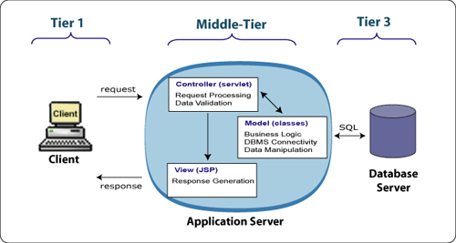

1. **THE PRESENTATION LAYER**

Also called as the client layer comprises of components that are dedicated to presenting the data to the user. For example: Windows/Web Forms and buttons, edit boxes, Text boxes, labels, grids, etc.

1. **THE BUSINESS RULES LAYER**

This layer encapsulates the Business rules or the business logic of the encapsulations. To have a separate layer for business logic is of a great advantage. This is because any changes in Business Rules can be easily handled in this layer. As long as the interface between the layers remains the same, any changes to the functionality/processing logic in this layer can be made without impacting the others. A lot of client-server apps failed to implement successfully as changing the business logic was a painful process

1. **THE DATA ACCESS LAYER**

This layer comprises of components that help in accessing the Database. If used in the right way, this layer provides a level of abstraction for the database structures. Simply put changes made to the database, tables, etc do not affect the rest of the application because of the Data Access layer. The different application layers send the data requests to this layer and receive the response from this layer.

1. **THE DATABASE LAYER**

This layer comprises of the Database Components such as DB Files, Tables, Views, etc. The Actual database could be created using SQL Server, Oracle, Flat files, etc.   
In an n-tier application, the entire application can be implemented in such a way that it is independent of the actual Database. For instance, you could change the Database Location with minimal changes to Data Access Layer. The rest of the Application should remain unaffected.

**External Interface Requirements**

3.1 User Interfaces

The application to be provided with keyboard shortcuts and a facility to use the mouse to trigger the required actions. They act as shortcuts and provide an easy navigation within the software. Error detection is handled by using Exception handling. Exception class is used to trap abnormal conditions and terminations.

3.2 Hardware Interfaces

The system requires an Internet connection with a decent band width. A printer in addition to take printouts of reports. A internet connection that is either thru dial-up, cable , modem, Wi-Fi is required. Appropriate networking and protocols should be.

3.3 Software Interfaces

The incoming data to the product would be raw text data and outgoing data would be text itself. Both input and output are handled thru dynamic HTML. A browser is required for access.

**Users of the System :**

1. Administrator
2. City Employees
3. Citizens
4. Visitors

**Modules of the System**

* + 1. Administrator Module
    2. City Employees(Sub Administrator) Module
    3. Water Management Module
    4. Authentication
    5. Reports

**Functional Requirements of the Project:**

**Administrator:**

**Water Management Studies:**

* Add Water Management Studies Information
* View Water Management Studies Information

**Enquiry**

* Post Water Information Enquiry.
* View Water Information Enquiry All Cities

**Water Management Regional’s:**

**States**

* Add New State Name
* View State
* Update State name
* Delete State Name

**District**

* Add District Names
* View District Names
* Delete District Names
* Update District Names

**City**

* Add New City Information With Map
* View All Cities Information.
* Update City Information
* Delete City Information

**2. City Employees:**

**Tips & Suggessitions:**

* Post Tips for City Citizens.
* View Tips of City Posted By Citizens.

**Complaints**

* Post Complaints about City.
* View Complaints of City Posted By Citizens.
* Give Solutions for Posted Complaints.

**Feedbacks:**

* Post feedback about city on particular event
* View feedbacks of City Posted By Citizens.
* Delete feedbacks of the city.

**3. Water Management Module**

**Water Supply**

* Add City Water Supply Timings(Area, Division wise and Contact Details)
* View Add City Water Supply Timings
* Update Add City Water Supply Timings
* Delete Add City Water Supply Timings

**Floods**

* Add real time floods Information
* View floods Information.
* Update floods Information.
* Delete floods Information.

**Water Management Projects**

* Add Projects(Waste water Management Project like…etc)
* View Projects
* Change Project information and status
* Delete Projects Information.

**Bacteria Containments in rivers and streams**

* Add Bacteria Containments in rivers and streams
* View Bacteria Containments in rivers and streams
* Delete Bacteria Containments information.

**Water management analysis and reports:**

* Add water Management Analysis and reports.
* View water Management Analysis and reports.
* Delete water Management Analysis and reports.

**Water safe water usage instructions:**

* Add safe water usage instructions
* View safe water usage instructions
* Delete safe water usage instructions

**Water Quality Concerns:**

* Add Water Quality Concerns
* View Water Quality Concerns
* Delete Water Quality Concerns

**4. Security and Authentication:**

* Login
* Logout
* Sub Admin(City Employees)Registration, Citizen Registration
* Change Passwords
* Forget Password
* View Profiles
* Update Profiles

**5. Reports**

**\*** Generating Different Format report to be download (.xls, pdf, html, txt)

**Front end (Store from front) Requirements**

**Administrator:**

**Water Management Studies:**

* Add Water Management Studies Information

**Enquiry**

* Post Water Information Enquiry.

**Water Management Regional’s:**

**States**

* Add New State Name
* Update State name

**District**

* Add District Names
* Delete District Names

**City**

* Add New City Information With Map
* Update City Information

**2. City Employees:**

**Tips & Suggessitions:**

* Post Tips for City Citizens.

**Complaints**

* Post Complaints about City.
* Give Solutions for Posted Complaints.

**Feedbacks:**

* Post feedback about city on particular event

**3. Water Management Module**

**Water Supply**

* Add City Water Supply Timings(Area, Division wise and Contact Details)
* Update Add City Water Supply Timings

**Floods**

* Add real time floods Information
* Update floods Information.

**Water Management Projects**

* Add Projects(Waste water Management Project like…etc)
* Change Project information and status

**Bacteria Containments in rivers and streams**

* Add Bacteria Containments in rivers and streams

**Water management analysis and reports:**

* Add water Management Analysis and reports.

**Water safe water usage instructions:**

* Add safe water usage instructions

**Water Quality Concerns:**

* Add Water Quality Concerns

**4. Security and Authentication:**

* Login
* Logout
* Sub Admin(City Employees)Registration, Citizen Registration
* Change Passwords
* Forget Password
* View Profiles
* Update Profiles

**5. Reports**

**\*** Generating Different Format report to be download (.xls, pdf, html, txt)

**4. Security and Authentication:**

* Login
* Logout
* Registration
* Change Passwords
* Forget Password
* Update Profiles

**Back end (Retrive from backend) Requirements :**

**Administrator:**

**Administrator:**

**Water Management Studies:**

* View Water Management Studies Information

**Enquiry**

View Water Information Enquiry All Cities

**Water Management Regional’s:**

**States**

* View State
* Delete State Name

**District**

* Add District Names
* Delete District Names

**City**

* View All Cities Information.
* Delete City Information

**2. City Employees:**

**Tips & Suggessitions:**

* View Tips of City Posted By Citizens.

**Complaints**

* View Complaints of City Posted By Citizens.
* Give Solutions for Posted Complaints.

**Feedbacks:**

* View feedbacks of City Posted By Citizens.
* Delete feedbacks of the city.

**3. Water Management Module**

**Water Supply**

* View Add City Water Supply Timings
* Delete Add City Water Supply Timings

**Floods**

* View floods Information.
* Delete floods Information.

**Water Management Projects**

* View Projects
* Delete Projects Information.

**Bacteria Containments in rivers and streams**

* View Bacteria Containments in rivers and streams
* Delete Bacteria Containments information.

**Water management analysis and reports:**

* View water Management Analysis and reports.
* Delete water Management Analysis and reports.

**Water safe water usage instructions:**

* View safe water usage instructions
* Delete safe water usage instructions

**Water Quality Concerns:**

* View Water Quality Concerns
* Delete Water Quality Concerns

**Security and Authentication:**

* View Profiles
* Update Profiles

**Reports**

**\*** Generating Different Format report To be download (.xls, pdf, html, txt)

5). Non Funtional Requirements

5.1 Usability Requirements

(As it is a Internet Application, must have some usabilty Features. End users of this System are Unlimited and from Various Skilled groups, so that we can’t restrict them. By providing some fecilities we have to make them comfortable.)

* Colors what we use in this Web Portal design are must be attractive.
* Fonts that uses for User Interface (Customer Store front) Design are must be in Uniform.
* Easy Navigations are freferable to do any task.
* Multiple flows (ways) are freferable to do any task.
* Home page Should be Centralized System (Screen/Window) to go to any feature and to get any result.
* The fecility to return to Home page from any page Should available.
* Labels of all Objects in the entire system Must be in Understadable form(Meaningful form).

5.1 Performance Requirements

(Application’s performance not only depends on application design also on Customers System’s Configuration (both Hardware and Software), Internet Access Speed, networks and Others)

Even though the performance is not only depends on application design, our application design and implimentation also responcible for the Performance.

* It has to load, with in the Industry Standard time.
* It has to support up to 2000 Concurrent users.
* It has to update the database in short time in order to reduce the stock verfication problems.

5.3 Compatibility Requirements

(As it is a Internet Application, it has to support various Hardware configurarions, Softwares and Network Communications)

It should support all types of Hardware versions, Operating Systems and Browsers